**Clark County Social Service**



**In-Home Services**

**Agency Handbook**

Homemaker Home Health Aide & Alternative Health Care Programs

HHHA | AHC | 2024

**TABLE OF CONTENTS**

Vision & Goals 2

Contact Information 3

Scope of Services

Important Forms 4-5

Client Expectations 6

Personal Care Attendant (PCA) Expectations 6-7

PCA Duties 7-8

Safety 9

Emergency Situations 9-10

Attachments

A: Plan of Care 11

B: Client Assignment Sheet 12

C: Client Receipt 13

D: HHHA/AHC Summary Invoice 14

E: Client Acknowledgement Form 15

**ADULT CARE SERVICES VISION**

To provide the opportunity for all people living with a disability or struggling with medical impairments to remain safely independent in their homes.

**GOAL 1:** Develop a prompt, efficient, and responsive system for the delivery of Personal Care Services (PCS) to individuals who do not have sufficient resources to meet their home and personal care needs.

**Programs Offered:**

**Homemaker Home Health Aide Program (HHHA)** assists individuals with household tasks they are unable to complete due to a medical condition so they can continue living independently in their homes.

**Alternative Health Care Program (AHC)** aids the transition from hospital to home and assists the client in returning to living independently.

**GOAL 2:** Develop and maintain strong partnerships with PCS agencies to deliver in home services that meet client needs.

**Partnership Strategies:**

Establish and maintain a contractual agreement between Clark County Social Service (CCSS) and PCS agencies for service delivery.

The CCSS staff will verify a household meets program criteria, complete an initial assessment, identify ongoing needs of clients, and create a Plan of Care (POC).

The CCSS staff will reach out to the PCS agency for availability of Personal Care Attendant (PCA) staff.

The PCS agency will assign and supervise PCA staff to ensure the client’s needs are being met.

The CCSS staff will maintain regular contact with clients to ensure they are receiving quality services.

The CCSS staff and PCS agency will communicate any identified issues, concerns, or additional needs of clients.



**CONTACT INFORMATION**

**Adult Care Services Unit Email:**

[SeniorServices@ClarkCountyNV.Gov](mailto:SeniorServices@ClarkCountyNV.Gov)

**CCSS Fiscal Unit Email:**

[CCSSFiscalServices@ClarkCountyNV.Gov](mailto:CCSSFiscalServices@ClarkCountyNV.Gov)

CCSS staff contact will be provided upon client assignment.

**IMPORTANT FORMS**

## pLAN OF cARE (poc)

Sample provided Attachment A, also refer to contract agreement Exhibit A/Attachment 1

* Provided for each client with details outlining the services requested and the number of days/hours approved per week.
* Cleaning services (limited to 2 hours per month) can only be provided in conjunction with another task/service.
* CCSS does not support medical supervision - PCA cannot administer medications or offer medical care/treatment.
* A client requesting duties outside the approved POC should be referred to the CCSS staff for review.

## cLIENT aSSIGNMENT sHEETS

Sample provided Attachment B, also refer to contract agreement Exhibit A/Attachment 3

* These forms should be completed by the PCA with each visit and reviewed/signed by the client after the service is completed. These forms are submitted to the CCSS Fiscal Unit monthly.
* If an error is found, please mark through the mistake, correct it above, and initial beside the correction.
* Do not sign for the client. If they are unable to sign, write an explanation in the comments section.
* Use the comments section to report any information the PCA feels is important to share about the client.
  + Examples: concerns regarding substance use, decline/improvements in the client’s environment or condition, serious family disturbances, additional people in the household, food shortage, suspicious activity, appearance of insects or pests, etc.

## cLIENT RECEIPT

Sample provided Attachment C, also refer to contract agreement Exhibit A/Attachment 4

* Utilize the Client Receipt whenever monetary transactions occur between a client and the PCA, such as grocery shopping.
* This receipt should accompany Attachment B for the date of purchase.

## hhhA/AHC SUMMARY INVOICE

Sample provided Attachment D, also refer to contract agreement Exhibit A/Attachment 2

* Submit to the CCSS Fiscal Unit monthly to include all services provided.
* Attach the Client Assignment Sheets (Attachment B) and Client Receipts (Attachment C) to the Summary Invoice.



## **CLIENT EXPECTATIONS**

* Clients will receive the POC (Attachment A) and a Client Acknowledgement Form (Attachment E) outlining the scope of services.
* Clients are informed to contact the PCS agency supervisor directly for any concerns regarding their PCA.
* Clients sign a Behavioral Contact in which inappropriate language, derogatory comments, disorderly conduct, and verbal/physical aggression will not be tolerated. If a client violates the Behavior Contract, a report should be made to the CCSS staff as soon as possible for appropriate action.
* Clients must be home for the duration of the PCA visit and must refrain from drinking or smoking during the service delivery.
* Clients will provide cleaning supplies such as mops, brushes, brooms, and cleaning products.
* Clients will provide money/card for the cost of laundry and for the cost of prescriptions/shopping items. See Client Receipt (Attachment C) for how to document these transactions.
* Clients are required to sign the weekly Client Assignment Sheet (Attachment B).

## **PERSONAL CARE ATTENDANT (PCA) EXPECTATIONS**

* Please encourage your PCA to dress in clothing that is appropriate for their job duties and wear an agency name tag / identification badge if available.
  + Upon initial contact, the PCA should introduce themselves, identify the agency they are from and confirm how the client would like to be addressed (Example: Hello, my name is Abigal from ABC Home Care, I’m here to see Joan Smith. How do you prefer to be addressed?)
* It is the responsibility of the PCA to safeguard their own personal items when providing in home services. It is highly encouraged not to bring large sums of money or valuables into the client’s home.
* The PCA should report unexpected absences of the client from the home or hospitalizations to the PCS agency supervisor and the CCSS staff as soon as possible.
* Bed bugs, insect infestation, unsanitary conditions due to urine/feces, and aggressive pets pose a safety concern for all parties and should be reported to the CCSS staff within 24 hours.
* Build positive rapport and create appropriate boundaries.
  + The PCA’s family and friends should not accompany them to the client’s home.
  + Client affairs are confidential. Please discuss ways to safeguard private information with your PCA and have the PCA communicate that plan with the client.
  + The PCA should refrain from sharing personal health information, religious beliefs, or political views with the client.
  + The PCA should limit personal calls and texts while providing services.
  + The PCA and client should maintain contact in a professional manner only.
  + If language is a barrier, please encourage PCA to use apps such as Google Translate to effectively communicate with clients while providing services.

## **PCA DUTIES**

**Bathing / Dressing / Grooming** – Transferring in/out of shower or stand by assistance, helping with dressing, applying lotion if client is unable, using an electric razor to assist with shaving, washing/brushing/drying hair, assistance with rollers/braiding if requested and time permits (seek direction from PCS agency supervisor). Notify PCS agency supervisor if there is a concern for the client’s safety (such as needing a bath chair, handrails, or to report a recent fall). These situations should also be reported to the CCSS staff.

**It is not permissible to clip fingernails/toenails, change bandages, or apply medicated ointments/lotions.**

**Shopping** – Food, cleaning supplies, hygiene products and picking up prescription medications. Immediately, upon returning to the client’s home, PCA will provide a client Receipt (Attachment C) and return card/provide cash change to client.

**It is not permissible to purchase alcohol for clients, accept gifts, or use clients’ funds for personal use.**

**Light housekeeping** – Dust, vacuum, sweep/mop, linen changes

* Kitchen: Countertops, surface of appliances, dishes, and a request can be made for a 1-time cleaning/defrosting of fridge when approved prior by the CCSS staff.
* Bathroom(used by client): Toilet bowl, base & riser, shower/tub, sink, countertop.

**Deep cleaning, yardwork, and decluttering are not provided.**

**Meal Preparation** – Cereal, precooked/microwavable meals, sandwiches, soups, and chopping/storing fruits and vegetables.

**It is not permissible to prepare full course meals from scratch or cook for guests/family members.**

**Laundry** – Laundering personal items, towels, and linens, folding/hanging/storage. Utilize on site laundry or nearest laundry service.

**It is not** **permissible to take a client’s personal items to your residence to wash or mend.**



## Warning with solid fill**Safety**

CCSS wants the PCA to be a safe, effective worker and to avoid injuries and illnesses caused by work assignments. Requests for the following activities should not be provided, and client requests for these activities should be reported when appropriate:

* Climbing on ladders, step stools or chairs
* Moving large furniture
* Using toxic chemicals or combining cleaning agents
* Hanging shelves, pictures, and curtain rods
* Turning, flipping, and lifting mattresses
* Lifting heavy loads, including bearing the full weight of clients or carrying multiple gallon containers of liquid
* Transporting clients in personal vehicles, using a client’s vehicle, asking for gas money from clients
* Asking for or accepting a key to the client’s home.
* Being left alone in the home without the client or regularly encountering nonresidents in the home
* Using appliances or equipment without prior training or knowledge

## **Emergency situations**

* If the PCA experiences a personal emergency or illness, and they are unable to complete their assignment, they should notify the PCS agency supervisor immediately to allow alternative arrangements to be made.
* If the client experiences an accident (such as a fall) or other medical emergency while the PCA is in the home or upon arrival to the home, the PCA should call 911 immediately. Please wait for emergency personnel to arrive and report the incident to the PCS agency supervisor. These situations should also be reported to the CCSS staff within 24 hours.
* Suicidal/homicidal intentions should be taken seriously and reported to 311 or 911 as appropriate. Encourage client to seek help from 988 Suicide and Crisis Lifeline or call with the client for immediate assistance. Report the incident to the PCS agency supervisor. These situations should also be reported to the CCSS staff within 24 hours.

**ATTACHMENT A**

**ATTACHMENT B**

**ATTACHMENT C**

**ATTACHMENT D**

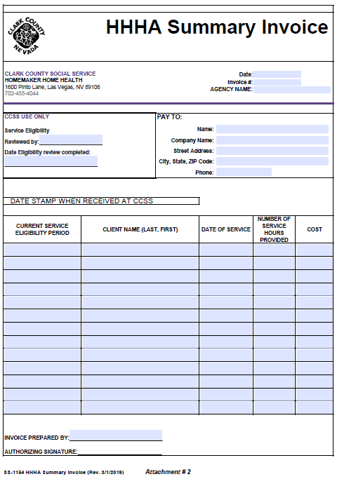

**ATTACHMENT E**

